<INSERT IMAGE HERE>  
(It should be representative to the gameplay and environment of the level)

Level Design Doc:

The Skittering Passages

Swords ‘n Shovels

Version 1.0

|  |  |
| --- | --- |
| Designer: | Barret Hudson |
| Document Date: | 06/15/2017 |
| Intended Level Delivery Date: | **TBD** |

Table of Contents

Quick Summary 3

Goals 4

Gameplay Overview 5

General Game Flow 5

Major Elements 6

Objective Summary 6

Technical Overview 7

Campaign 7

Mission Location 7

Mission Difficulty 7

Mission Metrics 8

Level Details 9

Level Atmosphere/Mood 9

Major Characters/Vehicles 9

Gameplay Mechanics 9

Story 9

“60 seconds of gameplay” 10

Visual References 11

Terrain/Vegetation 11

Models/Architecture 11

Textures/Lighting 11

Characters/Vehicles 11

Maps 12

Callout A/1/etc.: <Description of callout> 13

Callout B/2/etc.: <Description of callout> 13

Callout C/3/etc.: <Description of callout> 13

References 14

# Quick Summary

The Skittering Passages is a single player level for Swords n’ Shovels, built in the Unity engine. The level is set in a maze of tight corridors that twist and wind, connecting, splitting, and reconnecting with one another to form an unintelligible maze, deep in the abandoned dwarven mines underneath The Mountain of the Ancients. The level takes place after our hero and his companion, the last moon whisp, have progressed beyond the entry halls and primary mines, and is the player’s first taste of the darker, wilder, sections of the deeper mines. Filled with fast moving Streakers, the level requires players to keep a close eye on their minecart of loot or else they will lose all of their hard-earned materials. Forging ever deeper into the mines to find the source of the nightmares, the player must traverse The Skittering Passages, protecting themselves and their gathered loot from the Streakers, in order to progress to the next level of the mines. The level culminates in an exciting boss encounter with The Eye of The Dark, that tests the players mastery of their new turret skill. Defeating The Eye opens up the passage down.

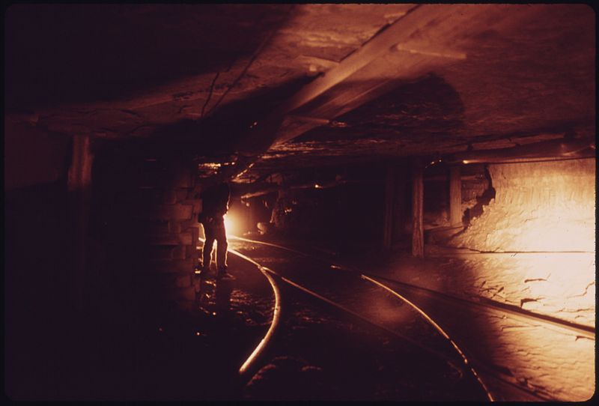

# Goals

1. Introduce the new enemy type Streakers in a fun and challenging, but non-threatening, environment, that plays to their strengths without overwhelming the player.
2. Introduce the turret and provide interesting gameplay centered around it
3. Amp up the tension and sense of darkness from the previous level to communicate the transition to the deeper mines

# Gameplay Overview

The Skittering Passages primary gameplay focus is on protecting your resources from fast moving enemies who try to steal it while you are trying to explore and make your way through a maze of twisting tunnels. The player must make it through the twisting passages and down to the next level of the mines. To do this, they will need the resources in their minecart in order to craft the tools required to beat the boss waiting at the end of the level. To complicate things, the Skittering Passages are full of Streakers, fast moving enemies who come from the shadows to steal the player’s resources when they least expect it.

To make it through with their resources intact, players need to master the use of the exploration and defense abilities of their whisp, allowing them to explore the passages while the whisp defends the cart and vice versa. There are too many pitfalls and traps that destroy the player’s minecart for them to explore with it. If players abandon their minecart completely though, their resources will get stolen and they won’t be able to craft the necessary equipment to defeat the boss of the level. Instead players must guard their cart full of precious resources at crossroads while also exploring the paths ahead to a safe way through.

## General Game Flow

The Skittering Passages has an overall linear flow that has several sections of gathered branching, where players can take several different paths, but they all wind up at the same place eventually. Players star the level by moving into a maze of passages, some which are passable, some which aren’t, eventually all passable options lead to a central room. From the central room, a large, obvious, exit leads into another maze of tunnels that eventually brings the player to the boss encounter and the path down to the next level.

*Include 1 or more flow maps, showing the important areas of the level and the players path through them. Be sure to include a legend with each map that includes a map scale so readers can get a feeling for the size of your level.*

## 

## Major Elements

* Battling new, fast-moving, enemies in a maze like set of corridors (Hook)
* Encountering a tentacled boss from the depths at the end of the level (WoW Moment)
* Finding the remains of a previous failed expedition into the mines (Story)
* Learning more about The Nightmares deep in the caverns(Story)
* Fighting enemies more concerned with stealing treasure than combat (New Gameplay)
* Learning to use the new Turret ability (New Gameplay)
* A maze-like environment of tight corridors (New Visual Element

## Objective Summary

The Skittering Passages’ objectives are:

* Survive
* Acquire the crafting plans for the turret
* Protect enough of your resources to craft the turret
* Defeat the final boss to move on to the next level

The overall objective of The Skittering Passages is to make it down to the next section of the mines. To do this they will have to beat a boss that requires them to use the turret ability that they acquire earlier in the level. Players can fail if they are killed or lose too many resources and can’t craft the turret, in which case the boss will kill them.

# Technical Overview

## Campaign

* Campaign – There is only one campaign in Swords n’ Shovels, covering the players journey into the depths of the mountain to defeat The Nightmares. The entire campaign takes place inside the mines and passages of the mountain, with the player moving ever deeper in search of answers about The Old Ones.
* Level Position in Campaign - The Skittering Passages is set in the latter portion of the first half of the campaign. The passages are the players first steps into the deeper, darker, regions of the mines, closer to The Nightmares. Prior to this the player was in the upper level mines, these were large and well worked areas with orderly passages. While they were abandoned and had some creatures in them, they didn’t feel ominous or evil. The Skittering Passage on the other hand is chaotic and feels ominous, foreshadowing the darkness that waits even deeper in the mines.

## Mission Location

* Theme – A cautious exploration into dark and twisting depths
* Mood – Ominous and tense, but not overly threatening or evil
* Setting – The missions takes place entirely within the confines of a section of mines
* Time of Day – NA inside a mine
* Season – NA Inside a mine
* Weather – NA Inside a mine

## Mission Difficulty

Scale: 1-10 (1 is Easiest and 10 is Hardest)

* Starting – 3: at the start of the mission players move through the passages and encounter few enemies, but must watch out for traps and weak sections of track that will destroy their cart
* Middle – 4: as the level progresses more enemies emerge, but they are mostly small groups or single streakers, players must protect their cart, but the combat is not challenging
* Ending – 6: The level culminates with a boss fight that requires players to move and think tactically, however, the boss is more of skill check and isn’t terribly difficult once players figure out the proper approach

## Mission Metrics

* Play Time – 10 minutes
* Physical Area – NA Level is procedurally generated so it varies
* New Characters –
  1. Streakers – Fast moving enemies that are more interested in stealing than fighting, they serve as a way to split the players attention between exploring and defending.
  2. Tentacle Boss – A large eye with ethereal tentacles. Serves as a skill check to make sure players have found the turret plans and learned how to use it.
* Visual Themes –
  1. The maze of passages – Relatively skinny passages that branch, turn, twist, and meet up at odd angles
  2. The central hub – A large open area containing an old mining elevator where ore from the passages used to be passed up to the upper levels on the mine, this area sits at the center of the passages.
  3. The Bosses Lair – A strange chamber with a central area and separate rooms spread around the outside, possible a storage room or prison initially, it appears to have been used to worship The Nightmares most recently.

# Level Details

## Level Atmosphere/Mood

The Skittering Passage’s mood is ominous but also makes players feel curios and explorative. Prior to the level the mines the player had been exploring had been well ordered and large, by comparison, the narrow passages in this level are chaotic and maze like. While this change causes some apprehension, the enemies and other challenges presented by the level are not overly threatening, so players feel free to explore the maze instead of feeling like they have to rush through it.

The following elements are used to convey the mood throughout the level:

* Narrow passages that don’t run in straight lines
* Irregular lighting, creating patches of light and darkness
* Light enemy resistance that keeps players alert, but isn’t particularly threatening
* A large central chamber where the player can see the remnants of an ancient battle that did not go well for the dwarves
* A final boss fight with a creature that reveals more about the nature of The Nightmares

## Major Characters/Vehicles

* The player character, a dwarf who has been thrown out of the city and explores the depths of the mines alone.
* The last moon wisp, the keeper of the mountain who befriends the main character when they are thrown out and leads them on their journey into the mountain
* Grunts, basic enemies used for gameplay
* Streakers, a new, more advanced, enemy type that is fast moving and tries to steal the player’s resources
* The boss, a large magical creature consisting of a large central eye and ethereal tentacles

## Gameplay Mechanics

* Prerequisite Skills –
  + Basic Movement
  + Moving the mine cart
  + Attacking
  + Digging
  + Commanding the wisp
  + Crafting
* Skills Learned –
  + Crafting turrets
  + Placing turrets

## Story

* Intro
  + The only intro to the level is a brief in game cinematic that shows the player descending a small set of stairs into the passages.
* In-Game
  + First players must make their way through a series of maze like passage, being careful not to get their minecart trapped or destroyed on dangerous tracks.
  + As they move deeper into the maze, streakers start to appear and players must defend their mine cart from these enemies who try to steal their resources.
  + Eventually players come to a large central chamber where they can see the remnants of an ancient battle between the dwarves and The Nightmares. A small combat encounter ensues and players discover the blueprint for the turret, unlocking the ability to craft them
  + Players move through another series of maze like tunnels, having to defend their minecart from more streakers and fight other enemies, there new turret skill comes in useful.
  + Eventually players arrive at the end of the maze where they encounter the boss in a large room divided by a central pillar with numerous barred off alcoves along the walls.
  + The boss alternates between sending its ethereal tentacles out into the room and using them to seal off its delicate eye in one of the alcoves.
  + Players use their turret and combat skills to defeat the boss, unlocking the passageway down to the next level.
* Extro
  + The only extro is a brief in game cinematic showing the player approaching and disappearing into the stairs.

## “60 seconds of gameplay”

“Having determined the appropriate path, the player starts off with their minecart, leaving the confusing intersection behind. As they round a corner in the dim passage, they see a bright intersection ahead, just as it comes into view, a dark figure flashes across the opening of the passage and disappears off to one side. Coming to yet another confusing intersection, and not wanting to risk their cart getting stuck or destroyed, they stop again and set off to explore their options. However, before they’ve even made it to the first passage, the dark figure returns again. First it hovers at the edge of the light, then darts out, making a beeline for the minecart and the treasures it holds. The player turns around and runs back to their cart, but they are too late, the creature has stolen one of their gems and made off down a side passage. The player wants to give chase, but who’s to say there aren’t more of the thieving creatures around, waiting to steal his treasure. Determined to get his gem back though, the player commands their wisp to guard the cart and sets off after the creature. Sure enough, as the player strays from their minecart another creature approaches, from a different direction this time. One flare of light from the wisp though sends the creature skittering back to the dark. Satisfied that their defenses will hold, the player plunges down the passage the first creature disappeared down… time to get that gem back!”

## Visual References

### Terrain/Vegetation

*If you have exterior environments include at least 3 to 4 reference images giving examples of the environment, vegetation, and terrain you expect*

### Models/Architecture

*If you have non-natural elements in your level, include at least 4 examples for what the buildings and other elements should look like.*

##### Textures/Lighting

*Provide at least 4 references for what you would like to see for wall/ground textures and level lighting.*

### Characters/Vehicles

*Provide at least 1 reference image for each character and vehicle you expect to use in the level including NPC’s and enemies.*

# Maps

*Include an over view map of the level and a series of detailed maps. The detailed maps should include:*

* *Lettered or numbered call outs for important gameplay encounters or moments*
* *Important enemy locations, spawn points, or paths*
* *Important pickups, powerups, or collectibles*
* *Important NPCs or interactable objects that players need to reach*

*Make sure every map has a legend and a scale so readers can interpret them.*

*(It may be useful to flip your page to portrait view to fit your map in)*

## Callout A/1/etc.: <Description of callout>

*This is a description of the first callout from your detailed maps Include a small image of the callout to help readers find it on the map and a brief description of what happens at this point.*

## Callout B/2/etc.: <Description of callout>

*These are just for the specific gameplay callouts, not everything on your detailed map*

## Callout C/3/etc.: <Description of callout>

*Repeat this for every callout in your detailed maps.*

# References

*Include links to where you found your various reference images and any other information you used when making your design such as lore pages or game world maps.*